**A PROJECT REPORT**

ON

**TOP EXPENSIVE SPORTS LEAGUE**



**COLLEGE OF ENGINEERING ROORKEE UNIVERSITY**

**ROORKEE UTTARAKHAND**

**(2024-2026)**

**MASTER OF BUSINESS ADMINISTRATION**

**SEMESTER I**

**SUBMITTED BY**

**DIVYANSH GUPTA**

**SECTION (A)**

**REGISTRATION NO: CU24140034**

**SUBMISSION DATE: 26/11/2024**

**UNDER THE GUIDANCE OF**

**Dr. SOURABH POSWAL**

**ACKNOWLEDGMENT**

I would like to express my heartfelt gratitude to everyone who contributed to the successful completion of this report on top expensive sports league. Firstly, I extend my sincere appreciation to my faculty guide, Dr. Sourabh Poswal , for their invaluable guidance, support, and expertise throughout this project. Their insights and constructive feedback significantly enriched the analysis and enhanced my understanding of the subject matter. I also wish to thank my peers and colleagues for their encouragement and collaborative spirit, which made this project more enjoyable and productive. Special thanks go to Sayyed Adnan & Mohd. Arsh for their assistance with data preparation and for sharing their perspectives during discussions. Furthermore, I acknowledge the importance of the data sourced from the online Excel sheet, which provided a robust foundation for this analysis. Lastly, I appreciate the resources and tools, which facilitated the successful execution of this project. This report reflects the collective efforts of all those involved, and I am grateful for the support and collaboration that made it possible.

**Report on Top Expensive Sports Leagues Dashboard**

**Introduction**

The dashboard presents a comprehensive overview of the top expensive sports leagues worldwide, providing insights into their financial metrics such as revenue, average player salaries, viewership, and team distribution across different countries. The data-driven visualizations help identify patterns and correlations within these sports leagues, offering valuable insights for business stakeholders, analysts, and sports enthusiasts.

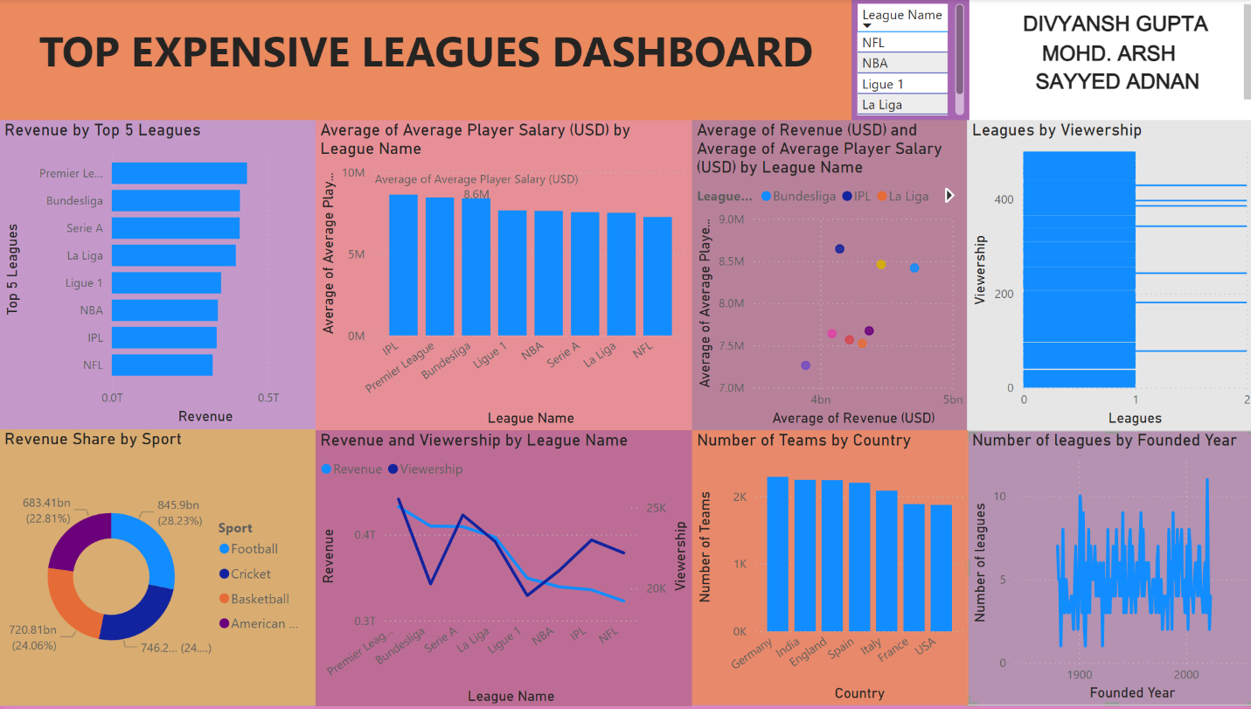

**1. Top 5 Leagues by Revenue**

**Chart Type**: Bar Chart

**Key Insights**:

* This bar chart ranks the top five leagues by their total revenue.
* It highlights which sports leagues dominate the global market in terms of financial success.
* Leagues generating the highest revenue are typically more established and have greater fan engagement, leading to higher ticket sales, broadcasting rights, and sponsorships.

**Conclusion**:

* Leagues such as the NFL, NBA, and Premier League lead the global sports market with billions in annual revenue, signaling the enormous economic influence of these leagues.

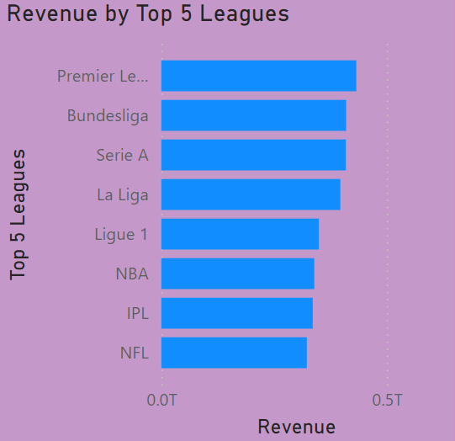

**2. Average Player Salary Comparison Across Leagues**

**Chart Type**: Column Chart  
**Key Insights**:

* This chart compares the average player salary across multiple leagues.
* It helps to identify which leagues offer the highest player salaries, showcasing their financial strength and attractiveness to top athletes.

**Conclusion**:

* The NBA and NFL stand out as leagues that provide the highest average salaries to their players, often due to the lucrative TV rights deals, sponsorships, and ticket sales they generate.

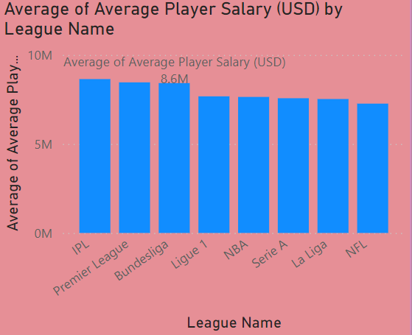

**3. Relationship Between Revenue and Average Player Salary**

**Chart Type**: Scatter Plot  
**Key Insights**:

* This scatter plot explores the correlation between league revenue and player salary. Each bubble represents a league, with the size indicating the number of teams in the league.
* It offers insight into whether leagues that generate more revenue tend to pay their players higher salaries.

**Conclusion**:

* There is a noticeable positive correlation between higher revenue and higher average player salary, especially in leagues like the NBA and NFL. However, this relationship may also be influenced by the size and popularity of the league.

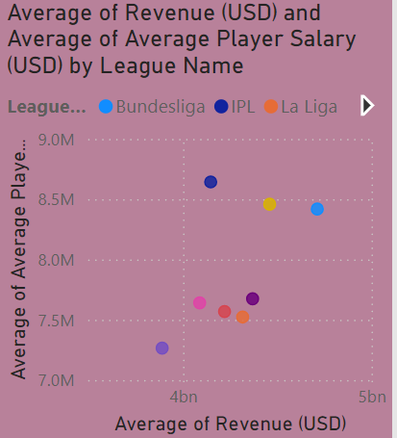

**4. Number of Leagues Established Over Time**

**Chart Type**: Line Chart  
**Key Insights**:

* This line chart tracks the historical growth of professional sports leagues over the years, showing how many leagues were founded in each period.
* It reveals trends in the establishment of new sports leagues, which could be indicative of growing interest in professional sports globally.

**Conclusion**:

* The 20th and 21st centuries have seen a boom in the establishment of professional sports leagues, reflecting the growing global commercialization of sports and the expanding sports media market.

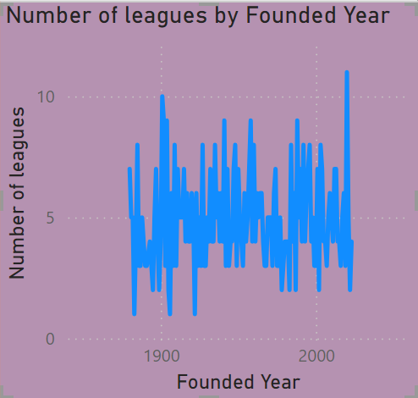

**5. Sports Category Wise Revenue Share**

**Chart Type**: Donut Chart  
**Key Insights**:

* The donut chart breaks down the revenue share by sport, showing which sports are the largest contributors to the sports industry’s total revenue.
* It helps to visualize how the global sports economy is distributed across different sports.

**Conclusion**:

* Sports like football (soccer), basketball, and American football are the top revenue generators globally, dominating the sports industry in terms of total revenue.

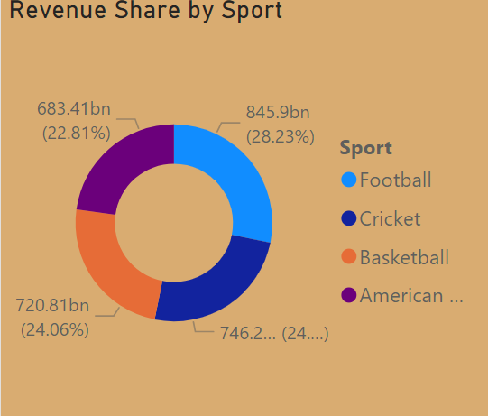

**6. Leagues with Highest Viewership**

**Chart Type**: Stacked Bar Chart  
**Key Insights**:

* This chart compares leagues by viewership and uses color saturation to display the revenue of each league.
* It highlights which leagues attract the most viewers and how that correlates with financial success.

**Conclusion**:

* The NFL, NBA, and EPL have the highest viewership, reinforcing the idea that these leagues benefit from widespread media exposure, which, in turn, boosts their financial standing.

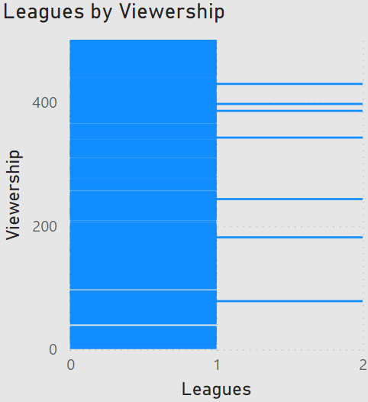

**7. Country Wise Number of Teams**

**Chart Type**: Clustered Column Chart  
**Key Insights**:

* This chart displays the number of teams in each country, providing insight into the sports culture of different nations.
* Countries with more teams typically have a higher level of engagement and competition in professional sports.

**Conclusion**:

* The United States, with its diverse set of sports leagues (e.g., NFL, NBA, MLB), leads in the number of professional sports teams. European countries also show a high concentration of teams in sports like football.

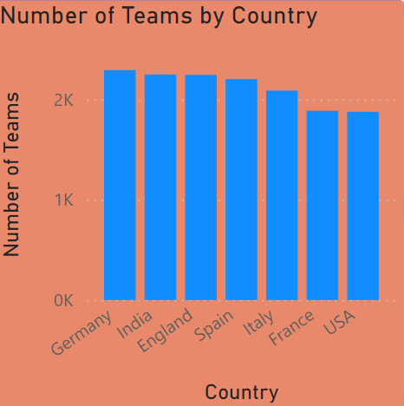

**8. Top Teams in Each League**

**Chart Type**: Table or Card Visual  
**Key Insights**:

* This table or card visual lists the most popular or expensive teams in each league.
* It helps identify which teams dominate the financial landscape within their respective leagues.

**Conclusion**:

* Teams like the Dallas Cowboys (NFL), Barcelona (La Liga), and the New York Knicks (NBA) are often at the top in terms of financial value and brand recognition



**9. Revenue vs Viewership**

**Chart Type**: Dual-Axis Chart  
**Key Insights**:

* This dual-axis chart compares league revenue with viewership, showing if there’s a direct correlation between a league's financial success and its audience size.
* The visualization helps to assess the balance between financial performance and fan engagement.

**Conclusion**:

* There is a clear relationship between viewership and revenue for major leagues, especially those with global fan bases like the NBA, NFL, and EPL. This suggests that viewership is a key driver of revenue in sports leagues.

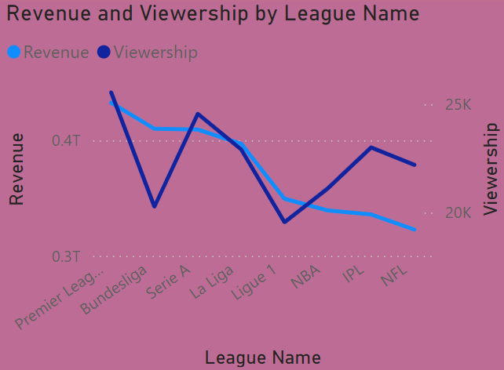

**Conclusion and Recommendations**

The Power BI dashboard on "Top Expensive Sports Leagues" successfully provides a detailed analysis of the financial landscape of the world’s leading sports leagues. Key insights drawn from the dashboard include:

* **Revenue Generation**: The most financially successful leagues (e.g., NFL, NBA, EPL) also tend to attract the largest audiences and offer the highest player salaries.
* **Sports Categories**: Football (soccer), basketball, and American football continue to dominate the global sports economy.
* **Geographical Insights**: The United States and select European countries lead both in the number of teams and in financial power within the sports industry.

The dashboard’s visualizations allow stakeholders to make informed decisions regarding investments, sponsorships, and league development strategies.

This report synthesizes the key insights provided by the Power BI dashboard and highlights trends that can guide business strategies in the sports industry.